AIML Assignment 1

Name – Gagan Sharma

Batch - 12

SAP id = 500122542

Roll No. = R2142230382

“Quality Education”

(SDG 4)

The various steps in the code comprises of the different models used to simplify the datasets so that the numerous factors that affect the quality of education. The in-depth analysis of the data gives different kinds of results, education being one of the biggest weapons to tackle various challenges faced by everyone in day-to-day life, moreover education the only way to make the world ready for upcoming threats and it can lead to development and betterment of society.

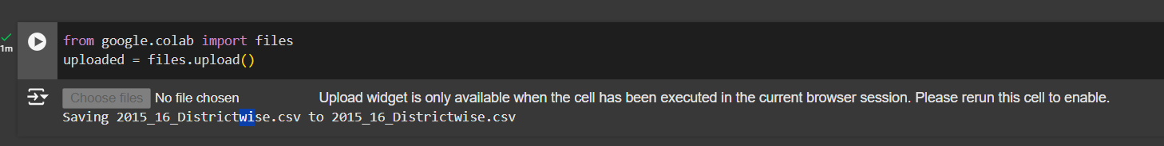

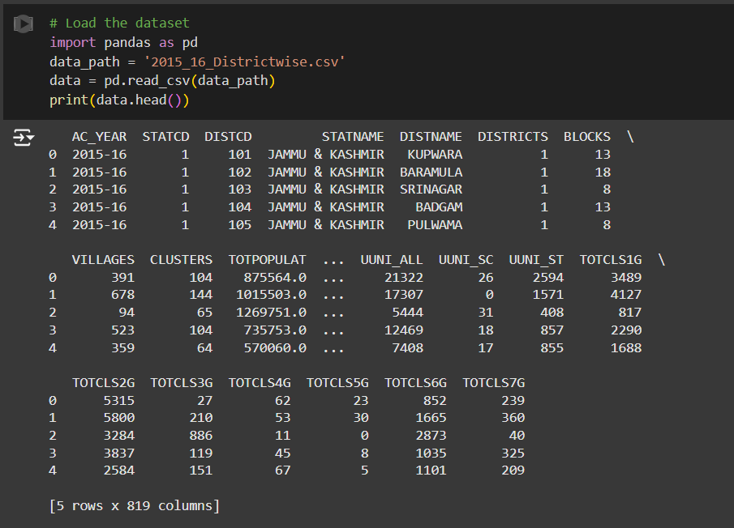

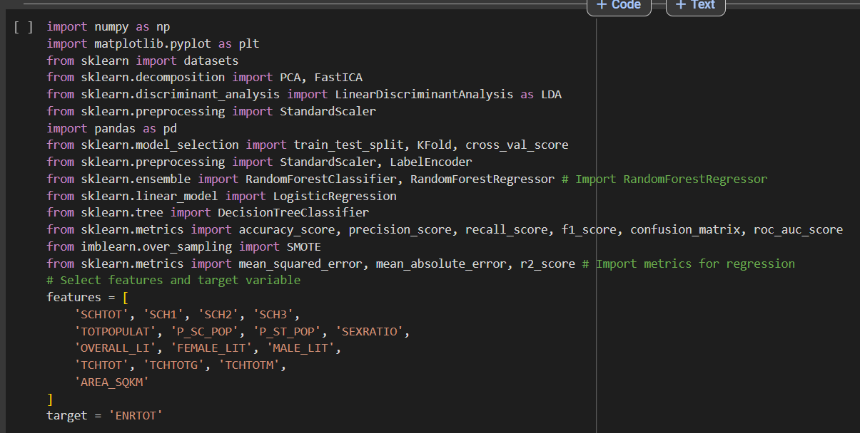

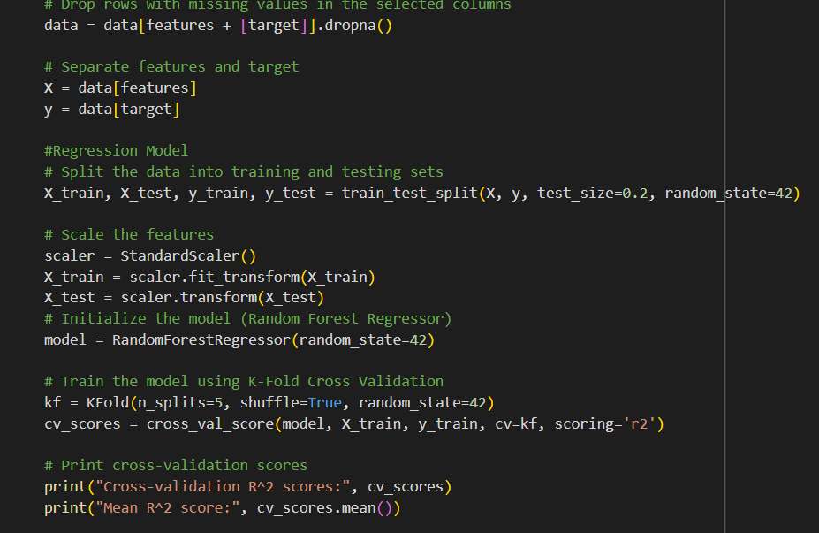

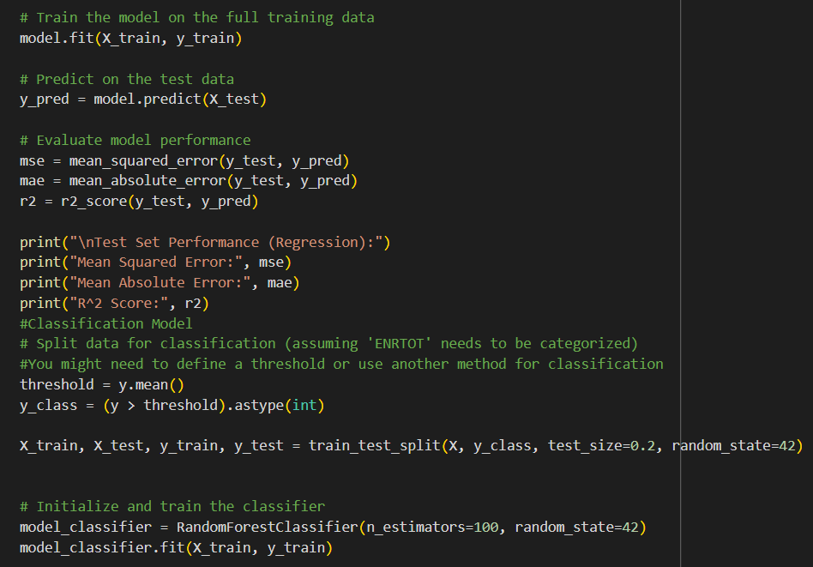

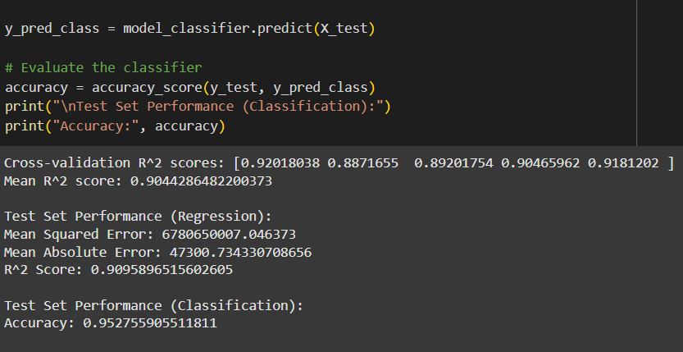

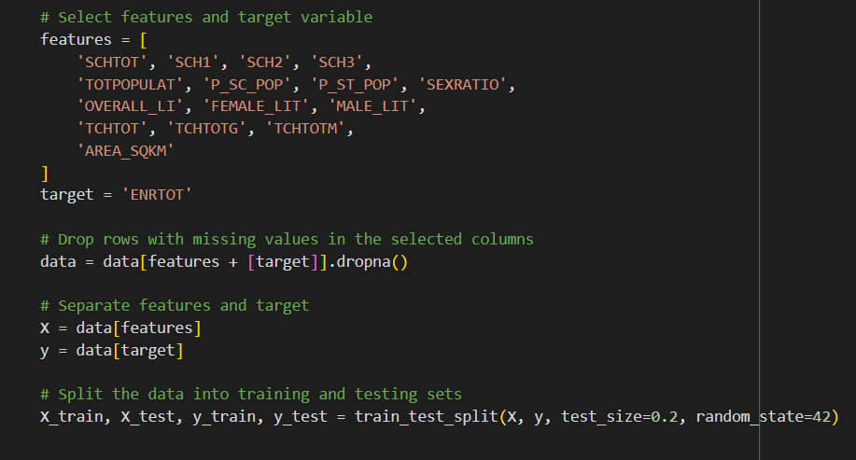

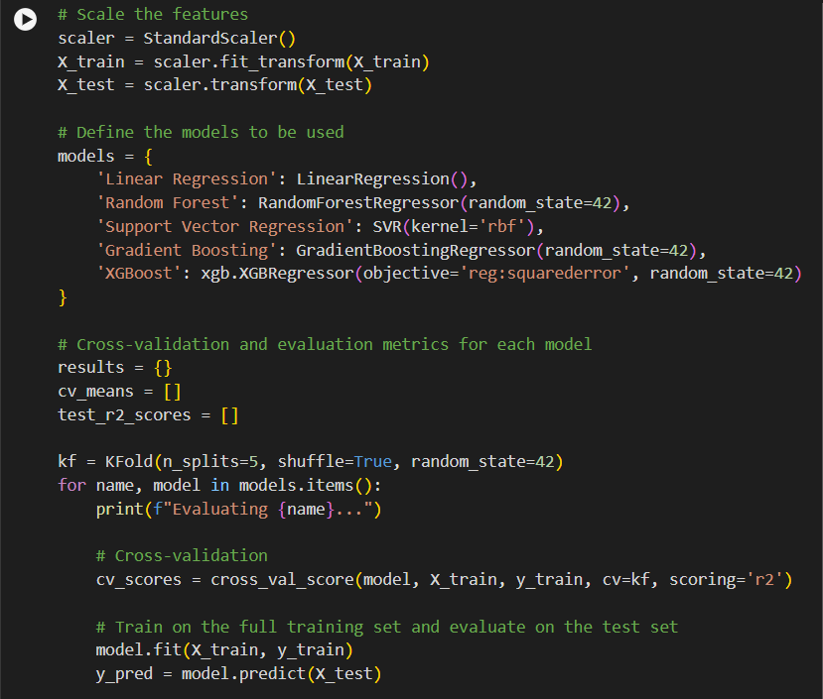

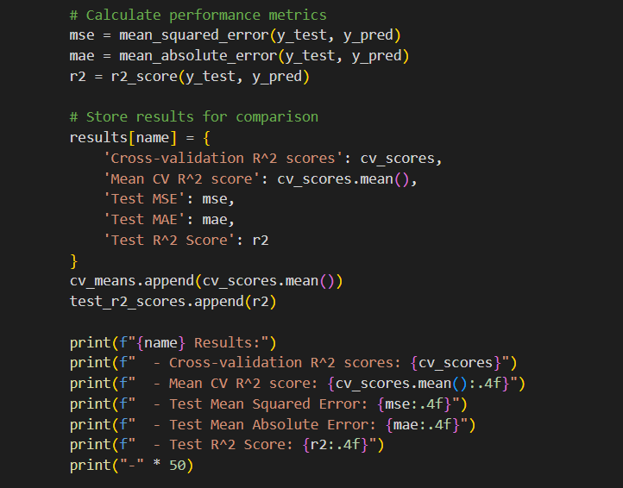

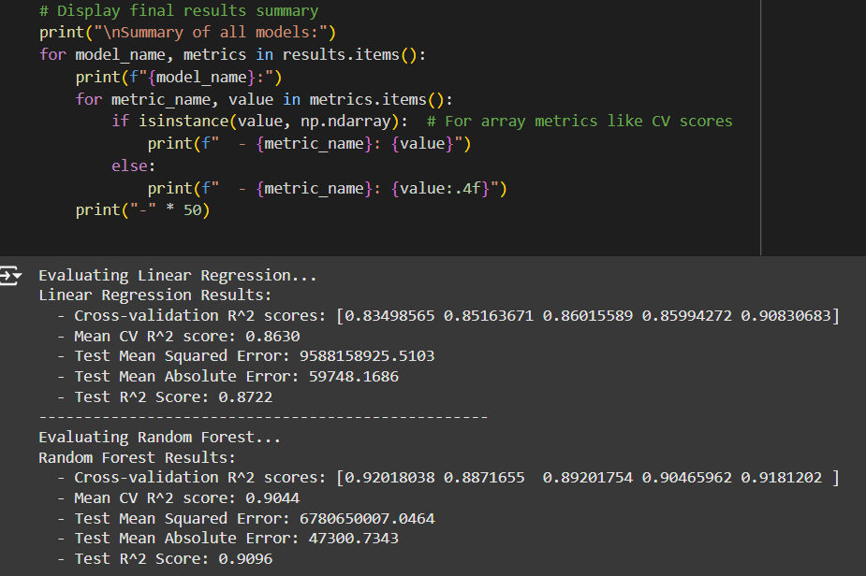

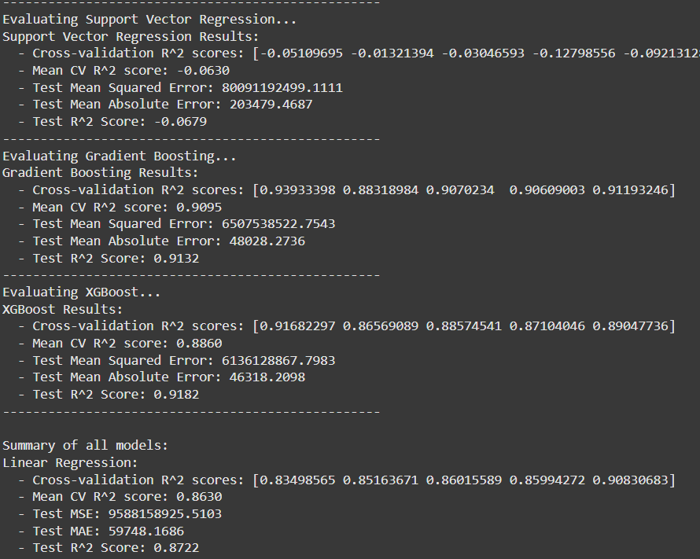

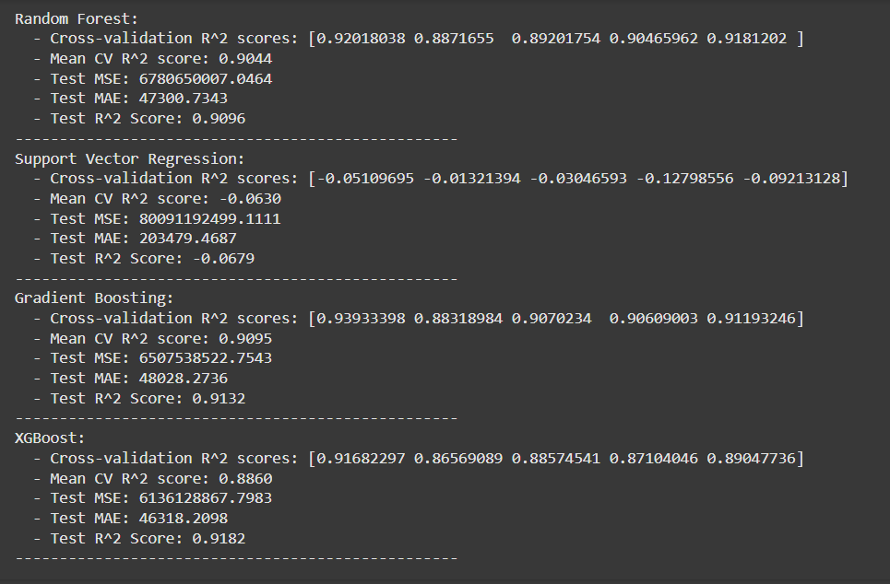

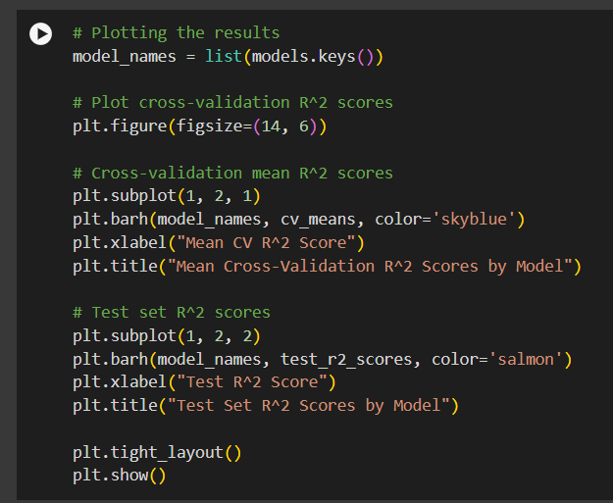

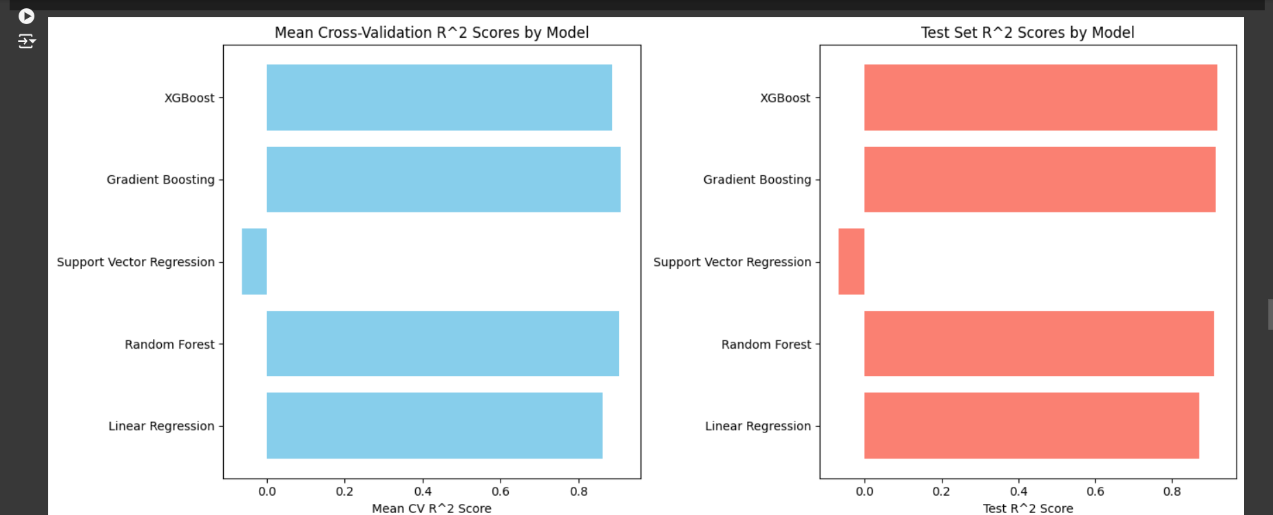

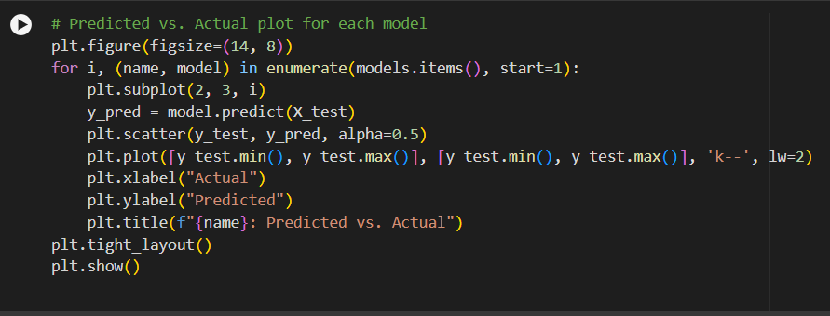

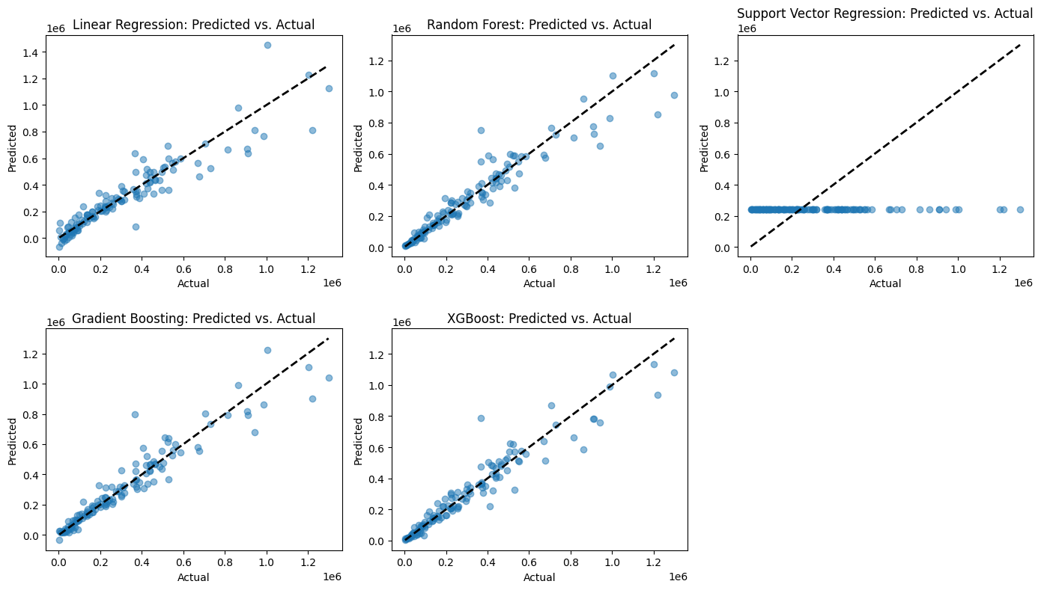

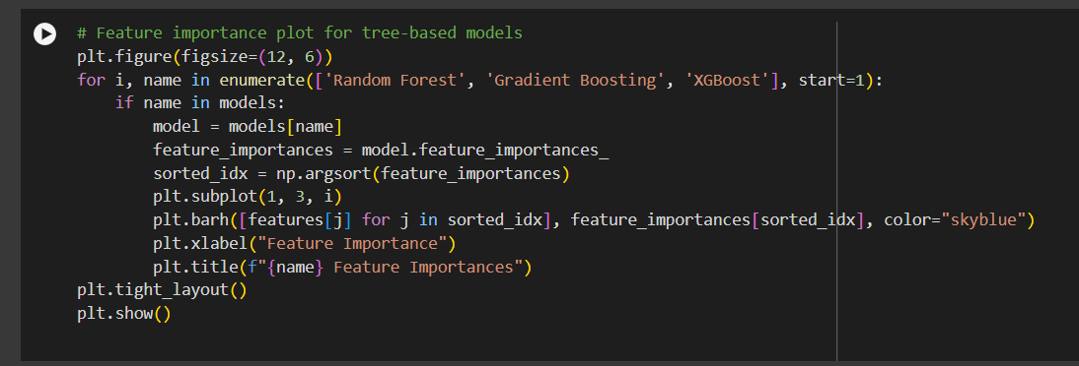

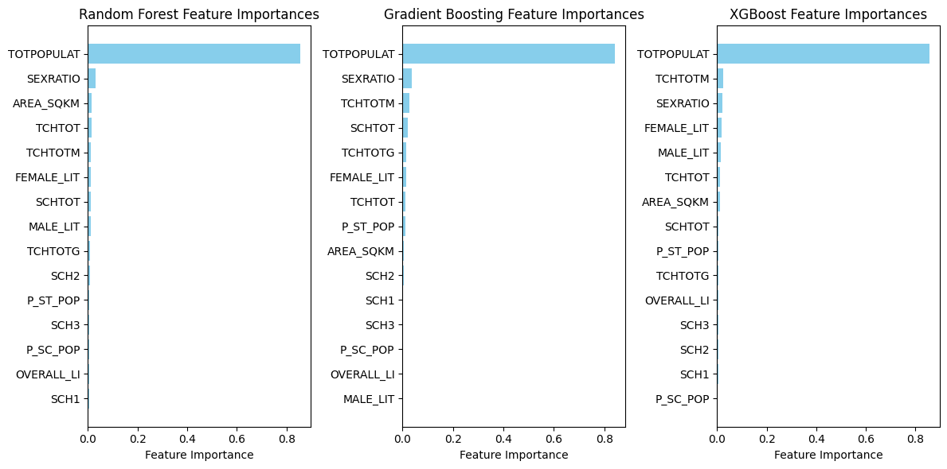

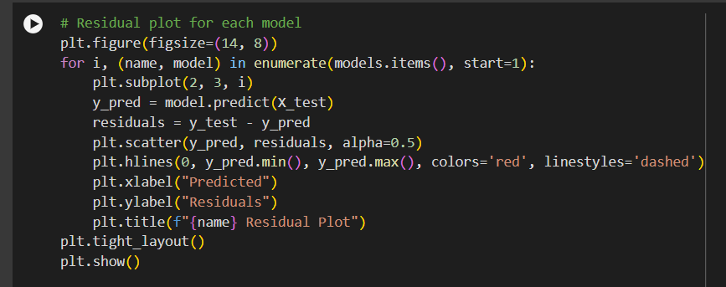

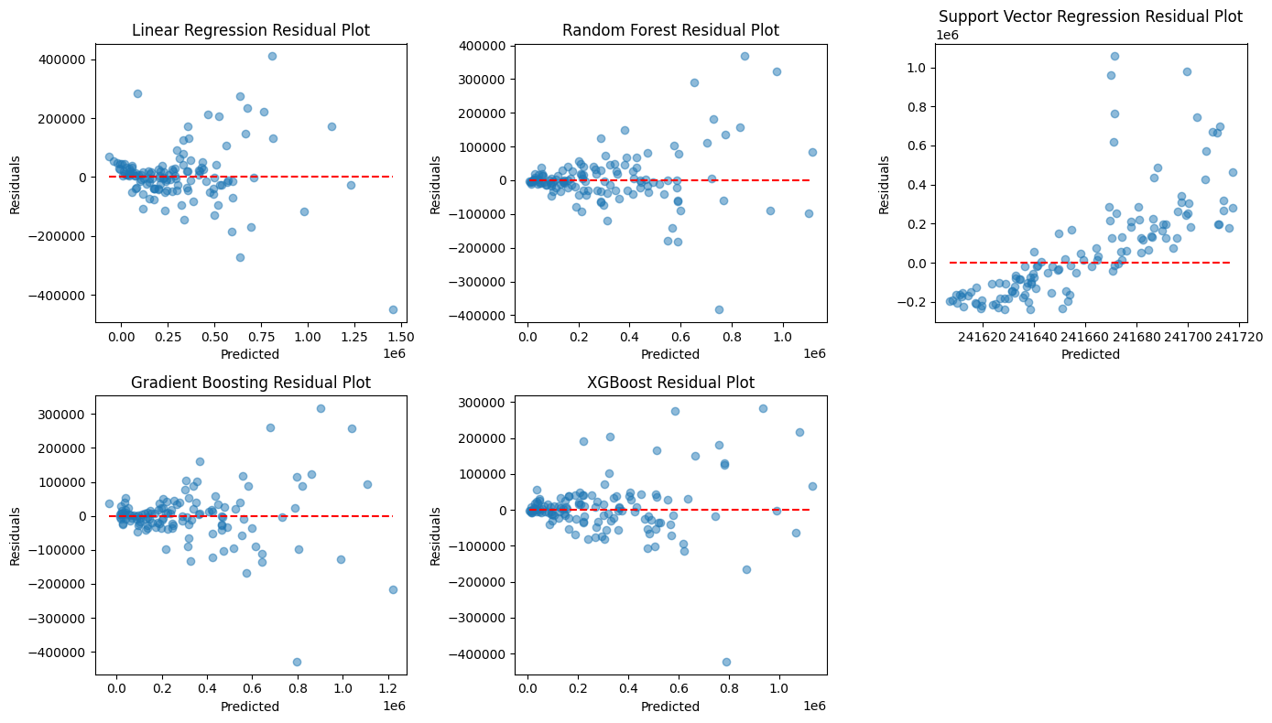

The problem revolves around the use of various educational datasets (SCHTOT, TOTPOPULAT, OVERALL_LI, etc.), which tend to suggest that the problem is associated with education analytics. For instance:

Impact of Policies: Forecasts may be helpful for governmental or academic institutions in making decisions regarding the distribution of resources, or implementing specific policies.

Resource Allocation: For instance, predicting correctly the number of enrolees at schools helps to make arrangements for building the school structures, engaging more teachers, or preparing the resources for the expanding number of people.

Educational Planning: Model predictions may also be useful in understanding the impact of enrolment drivers such as literacy or gender ratios or the number of teachers available.

The several models that were experimented with namely, linear regression, ensemble methods and others, worked to achieve the goal of ‘prediction’ of ENRTOT variables from a given set of predictors. This presents both practical recommendations as well as statistical estimates in the process of engaging in educational planning.

The objective of the program is to conduct a regression task concerning the variable ENRTOT which can be understood as total enrolment in school or some variable in that context. The challenge is to see how various features, mostly the demographics, literacy rates, the number of schools and teachers, and the area covered affect this target. It could particularly be answering questions like the following:

“Which parameters tend to affect total school enrolment?”

“Is it possible to carry out a prediction of the school enrolment using the demographic and education features of a region?”

Important Procedures in Reorienting the Model for Quality Assessment:

When it comes to assessing educational quality, include the following:

Statistics regarding the academic achievement of students (their examination and literacy scores).

Information about the infrastructure available (size of the classrooms, access to library or laboratories).

Details about the teachers’ qualifications and years of teaching experience, since they directly affect educational quality.

In short, although this model is now geared towards predicting enrolment, it can take a step further and include other indicators at the cost of being earmarked for the purposes of quality improvement in education, by focusing on areas which require additional resources or policy interventions.